Q1:Write a program to perform various operations in the list:
- Insertion
- Deletion
- Display

#include <stdio.h>

#define MAX 100

int main() {
int arr[MAX], n = 0, choice, pos, value, i;

while (1) {
printf("\n---- List Operations ----\n");
printf("1. Insert\n");
printf("2. Delete\n");
printf("3. Display\n");
printf("4. Exit\n");
printf("Enter your choice: ");
scanf("%d", &choice);

switch (choice) {
case 1: // Insertion
if (n == MAX) {
printf("List is full. Cannot insert.\n");
} else {
printf("Enter position to insert (1 to %d): ", n + 1);
scanf("%d", &pos);
printf("Enter value to insert: ");
scanf("%d", &value);

if (pos < 1 || pos > n + 1) {
printf("Invalid position!\n");
} else {
for (i = n - 1; i >= pos - 1; i--) {
arr[i + 1] = arr[i];
}
arr[pos - 1] = value;
n++;
printf("Inserted successfully!\n");
}
}
break;

case 2: // Deletion
if (n == 0) {
printf("List is empty. Nothing to delete.\n");
} else {
printf("Enter position to delete (1 to %d): ", n);
scanf("%d", &pos);

if (pos < 1 || pos > n) {
printf("Invalid position!\n");
} else {
for (i = pos - 1; i < n - 1; i++) {
arr[i] = arr[i + 1];
}
n--;
printf("Deleted successfully!\n");
}
}
break;

case 3: // Display
if (n == 0) {
printf("List is empty.\n");
} else {
printf("List elements: ");
for (i = 0; i < n; i++) {
printf("%d ", arr[i]);
}
printf("\n");
}
break;

case 4:
printf("Exiting program...\n");
return 0;

default:
printf("Invalid choice! Try again.\n");
}
}
}
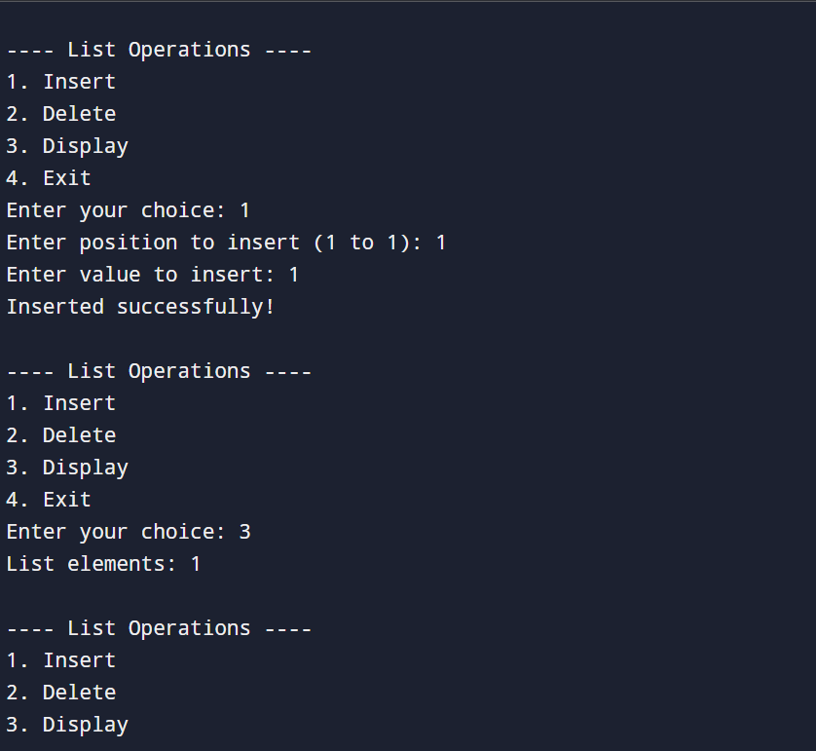

Q2:Write a program to find the arithmetic operations on matrices:
- Sum and Subtraction
- Product of 2 matrices
- Transpose of a matrix

#include <stdio.h>

int main() {
int a[10][10], b[10][10], c[10][10];
int r1, c1, r2, c2;
int i, j, k, choice;

while (1) {
printf("\n---- Matrix Operations ----\n");
printf("1. Sum of Two Matrices\n");
printf("2. Subtraction of Two Matrices\n");
printf("3. Product of Two Matrices\n");
printf("4. Transpose of a Matrix\n");
printf("5. Exit\n");
printf("Enter your choice: ");
scanf("%d", &choice);

switch (choice) {

case 1: // Sum
printf("Enter rows and columns of matrices: ");
scanf("%d %d", &r1, &c1);

printf("Enter Matrix A:\n");
for (i = 0; i < r1; i++)
for (j = 0; j < c1; j++)
scanf("%d", &a[i][j]);

printf("Enter Matrix B:\n");
for (i = 0; i < r1; i++)
for (j = 0; j < c1; j++)
scanf("%d", &b[i][j]);

printf("Sum of matrices:\n");
for (i = 0; i < r1; i++) {
for (j = 0; j < c1; j++) {
c[i][j] = a[i][j] + b[i][j];
printf("%d ", c[i][j]);
}
printf("\n");
}
break;

case 2: // Subtraction
printf("Enter rows and columns of matrices: ");
scanf("%d %d", &r1, &c1);

printf("Enter Matrix A:\n");
for (i = 0; i < r1; i++)
for (j = 0; j < c1; j++)
scanf("%d", &a[i][j]);

printf("Enter Matrix B:\n");
for (i = 0; i < r1; i++)
for (j = 0; j < c1; j++)
scanf("%d", &b[i][j]);

printf("Subtraction of matrices (A - B):\n");
for (i = 0; i < r1; i++) {
for (j = 0; j < c1; j++) {
c[i][j] = a[i][j] - b[i][j];
printf("%d ", c[i][j]);
}
printf("\n");
}
break;

case 3: // Product
printf("Enter rows and columns of Matrix A: ");
scanf("%d %d", &r1, &c1);

printf("Enter rows and columns of Matrix B: ");
scanf("%d %d", &r2, &c2);

if (c1 != r2) {
printf("Matrix multiplication not possible.\n");
break;
}

printf("Enter Matrix A:\n");
for (i = 0; i < r1; i++)
for (j = 0; j < c1; j++)
scanf("%d", &a[i][j]);

printf("Enter Matrix B:\n");
for (i = 0; i < r2; i++)
for (j = 0; j < c2; j++)
scanf("%d", &b[i][j]);

// Initialize product matrix
for (i = 0; i < r1; i++)
for (j = 0; j < c2; j++)
c[i][j] = 0;

// Multiply
for (i = 0; i < r1; i++)
for (j = 0; j < c2; j++)
for (k = 0; k < c1; k++)
c[i][j] += a[i][j] * b[k][j]; // mistake here? Actually should be: a[i][k] * b[k][j]

printf("Product of matrices:\n");
for (i = 0; i < r1; i++) {
for (j = 0; j < c2; j++)
printf("%d ", c[i][j]);
printf("\n");
}
break;

case 4: // Transpose
printf("Enter rows and columns of Matrix: ");
scanf("%d %d", &r1, &c1);

printf("Enter Matrix:\n");
for (i = 0; i < r1; i++)
for (j = 0; j < c1; j++)
scanf("%d", &a[i][j]);

printf("Transpose of Matrix:\n");
for (i = 0; i < c1; i++) {
for (j = 0; j < r1; j++)
printf("%d ", a[j][i]);
printf("\n");
}
break;

case 5:
return 0;

default:
printf("Invalid choice! Try again.\n");
}
}
}
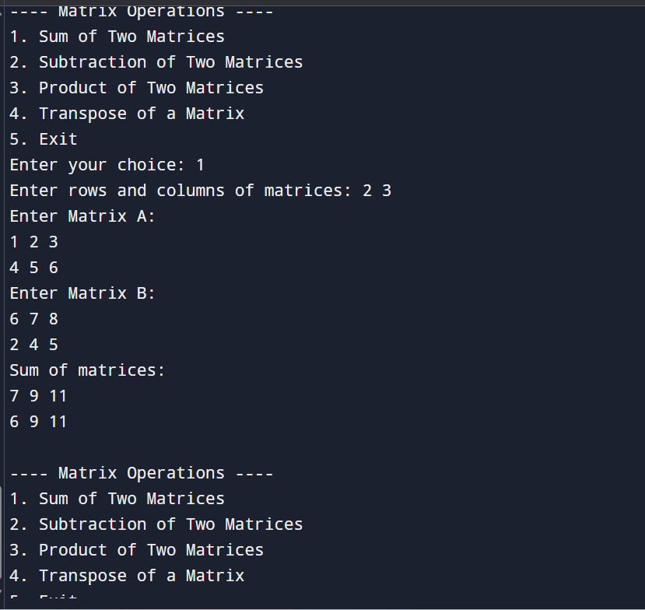
Q3:Write a Program to sort the list using:
- Bubble Sort
- Quick Sort
- Insertion sort
- Merge Sort
- Heap Sort
Also, find the comparison on the basis of time complexity.
#include <stdio.h>

void bubble(int a[], int n) {
int i, j, t;
for(i=0;i<n-1;i++)
for(j=0;j<n-i-1;j++)
if(a[j] > a[j+1]) { t=a[j]; a[j]=a[j+1]; a[j+1]=t; }
}

void insertion(int a[], int n) {
int i, j, key;
for(i=1;i<n;i++) {
key = a[i];
j = i-1;
while(j>=0 && a[j] > key) {
a[j+1] = a[j];
j--;
}
a[j+1] = key;
}
}

void quick(int a[], int low, int high) {
int i = low, j = high, pivot = a[(low+high)/2], t;
while(i <= j) {
while(a[i] < pivot) i++;
while(a[j] > pivot) j--;
if(i <= j) { t=a[i]; a[i]=a[j]; a[j]=t; i++; j--; }
}
if(low < j) quick(a, low, j);
if(i < high) quick(a, i, high);
}

void mergeArr(int a[], int l, int m, int h) {
int i=l, j=m+1, k=0, b[100];
while(i<=m && j<=h)
b[k++] = (a[i] < a[j]) ? a[i++] : a[j++];
while(i<=m) b[k++] = a[i++];
while(j<=h) b[k++] = a[j++];
for(i=l, k=0; i<=h; i++, k++) a[i] = b[k];
}

void merge(int a[], int l, int h) {
if(l < h) {
int m = (l+h)/2;
merge(a,l,m);
merge(a,m+1,h);
mergeArr(a,l,m,h);
}
}

void heapify(int a[], int n, int i) {
int l=2*i+1, r=2*i+2, largest=i, t;
if(l<n && a[l]>a[largest]) largest=l;
if(r<n && a[r]>a[largest]) largest=r;
if(largest!=i) { t=a[i]; a[i]=a[largest]; a[largest]=t; heapify(a,n,largest); }
}

void heap(int a[], int n) {
int i, t;
for(i=n/2-1;i>=0;i--) heapify(a,n,i);
for(i=n-1;i>0;i--) {
t=a[0]; a[0]=a[i]; a[i]=t;
heapify(a,i,0);
}
}

void print(int a[], int n) {
int i;
for(i=0;i<n;i++) printf("%d ", a[i]);
}

int main() {
int a[50], n, ch, i;

printf("Enter n: ");
scanf("%d", &n);
printf("Enter elements: ");
for(i=0;i<n;i++) scanf("%d",&a[i]);

printf("\n1.Bubble 2.Quick 3.Insertion 4.Merge 5.Heap\nChoice: ");
scanf("%d", &ch);

if(ch==1) bubble(a,n);
else if(ch==2) quick(a,0,n-1);
else if(ch==3) insertion(a,n);
else if(ch==4) merge(a,0,n-1);
else if(ch==5) heap(a,n);
else printf("Invalid!");

printf("\nSorted List: ");
print(a,n);

printf("\n\nTime Complexity:\n");
printf("Bubble Sort : O(n^2)\n");
printf("Insertion Sort : O(n^2)\n");
printf("Quick Sort : O(n log n)\n");
printf("Merge Sort : O(n log n)\n");
printf("Heap Sort : O(n log n)\n");

return 0;
}
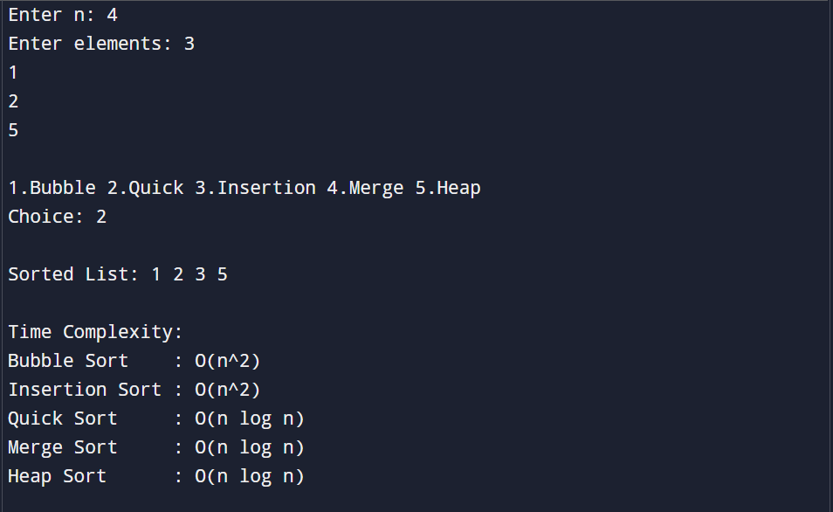

Q4:Write a program to search the element using:
- Linear Search
- Binary Search
Also, find the comparison on the basis of time complexity.
#include <stdio.h>

int linearSearch(int a[], int n, int x) {
int i;
for(i = 0; i < n; i++)
if(a[i] == x)
return i;
return -1;
}

int binarySearch(int a[], int n, int x) {
int l = 0, r = n - 1, mid;
while(l <= r) {
mid = (l + r) / 2;
if(a[mid] == x) return mid;
else if(a[mid] < x) l = mid + 1;
else r = mid - 1;
}
return -1;
}

int main() {
int a[50], n, i, x, choice, pos;

printf("Enter number of elements: ");
scanf("%d", &n);

printf("Enter sorted elements: ");
for(i = 0; i < n; i++)
scanf("%d", &a[i]);

printf("Enter element to search: ");
scanf("%d", &x);

printf("\n1. Linear Search\n2. Binary Search\nChoice: ");
scanf("%d", &choice);

if(choice == 1) {
pos = linearSearch(a, n, x);
if(pos == -1) printf("Element not found.\n");
else printf("Element found at position %d\n", pos+1);
}
else if(choice == 2) {
pos = binarySearch(a, n, x);
if(pos == -1) printf("Element not found.\n");
else printf("Element found at position %d\n", pos+1);
}
else {
printf("Invalid choice.\n");
}

printf("\nTime Complexity:\n");
printf("Linear Search : O(n)\n");
printf("Binary Search : O(log n)\n");

return 0;
}
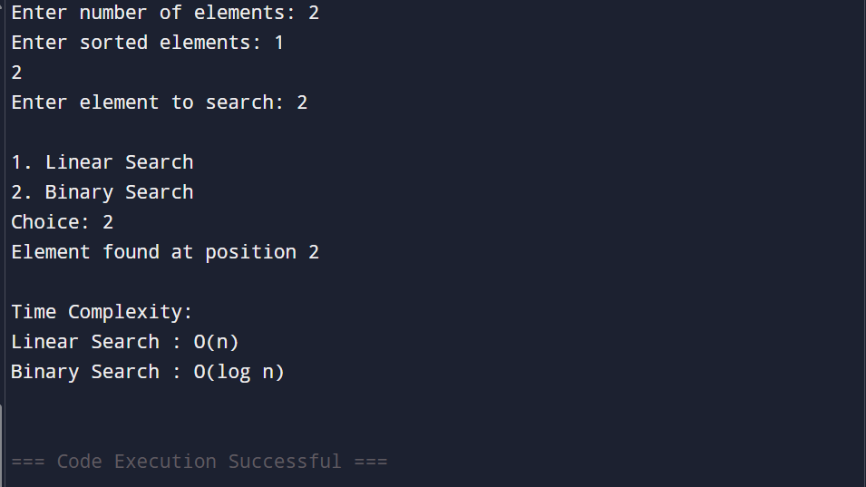

Q5:Write a program to perform all operations:
-For the Stack using an Array.
-For the Queue using an Array.
- For the Circular Queue using an Array.

#include <stdio.h>
#define SIZE 5

int stack[SIZE], top = -1;
int queue[SIZE], front = -1, rear = -1;
int cqueue[SIZE], cfront = -1, crear = -1;

/* ------ STACK OPERATIONS ------ */
void push(int x) {
if(top == SIZE-1) printf("Stack Overflow\n");
else stack[++top] = x;
}

void pop() {
if(top == -1) printf("Stack Underflow\n");
else printf("Popped: %d\n", stack[top--]);
}

void displayStack() {
if(top == -1) printf("Stack Empty\n");
else {
printf("Stack: ");
for(int i=0;i<=top;i++) printf("%d ", stack[i]);
printf("\n");
}
}

/* ------ QUEUE OPERATIONS ------ */
void enqueue(int x) {
if(rear == SIZE-1) printf("Queue Full\n");
else {
if(front == -1) front = 0;
queue[++rear] = x;
}
}

void dequeue() {
if(front == -1 || front > rear) printf("Queue Empty\n");
else printf("Deleted: %d\n", queue[front++]);
}

void displayQueue() {
if(front == -1 || front > rear) printf("Queue Empty\n");
else {
printf("Queue: ");
for(int i=front;i<=rear;i++) printf("%d ", queue[i]);
printf("\n");
}
}

/* ------ CIRCULAR QUEUE OPERATIONS ------ */
void cenqueue(int x) {
if((cfront == 0 && crear == SIZE-1) || (crear + 1 == cfront))
printf("Circular Queue Full\n");
else {
if(cfront == -1) cfront = 0;
crear = (crear + 1) % SIZE;
cqueue[crear] = x;
}
}

void cdequeue() {
if(cfront == -1) printf("Circular Queue Empty\n");
else {
printf("Deleted: %d\n", cqueue[cfront]);
if(cfront == crear) cfront = crear = -1;
else cfront = (cfront + 1) % SIZE;
}
}

void displayCQueue() {
if(cfront == -1) printf("Circular Queue Empty\n");
else {
int i = cfront;
printf("Circular Queue: ");
while(1) {
printf("%d ", cqueue[i]);
if(i == crear) break;
i = (i + 1) % SIZE;
}
printf("\n");
}
}

/* ------ MAIN ------ */
int main() {
push(10); push(20); push(30);
displayStack();
pop();
displayStack();

printf("\n");

enqueue(5); enqueue(15); enqueue(25);
displayQueue();
dequeue();
displayQueue();

printf("\n");

cenqueue(1); cenqueue(2); cenqueue(3);
displayCQueue();
cdequeue();
displayCQueue();

return 0;
}

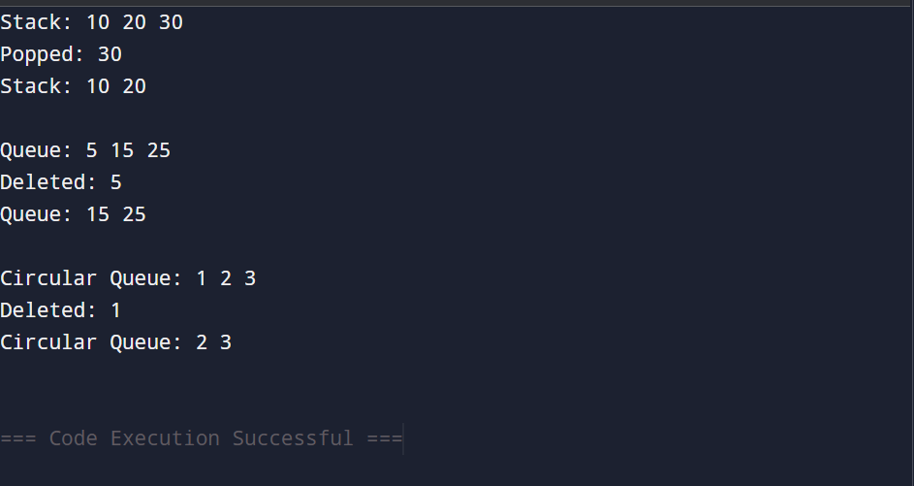

Q6: Write a program to evaluate the Postfix Notation.

#include <stdio.h>
#include <ctype.h>

int stack[50], top = -1;

void push(int x) {
stack[++top] = x;
}

int pop() {
return stack[top--];
}

int main() {
char exp[50];
int i, a, b;

printf("Enter postfix expression: ");
scanf("%s", exp);

for(i = 0; exp[i] != '\0'; i++) {
if(isdigit(exp[i])) {
push(exp[i] - '0');
}
else {
b = pop();
a = pop();
switch(exp[i]) {
case '+': push(a + b); break;
case '-': push(a - b); break;
case '*': push(a * b); break;
case '/': push(a / b); break;
}
}
}

printf("Result = %d\n", pop());
return 0;
}
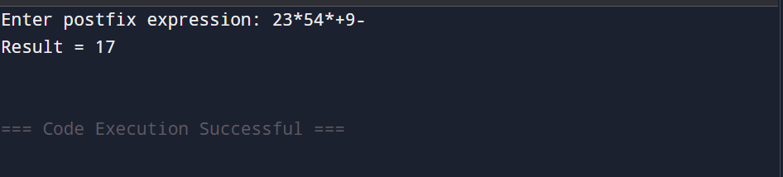

Q7:Write a program to convert infix notation into Postfix Notation.

#include <stdio.h>
#include <ctype.h>

char stack[50];
int top = -1;

void push(char x) { stack[++top] = x; }
char pop() { return stack[top--]; }

int priority(char x) {
if (x == '(') return 0;
if (x == '+' || x == '-') return 1;
if (x == '*' || x == '/') return 2;
return 0;
}

int main() {
char infix[50], postfix[50];
int i, j = 0;

printf("Enter Infix Expression: ");
scanf("%s", infix);

for (i = 0; infix[i] != '\0'; i++) {
char ch = infix[i];

if (isalnum(ch))
postfix[j++] = ch;
else if (ch == '(')
push(ch);
else if (ch == ')') {
while (stack[top] != '(')
postfix[j++] = pop();
pop();
}
else {
while (top != -1 && priority(stack[top]) >= priority(ch))
postfix[j++] = pop();
push(ch);
}
}

while (top != -1)
postfix[j++] = pop();

postfix[j] = '\0';

printf("Postfix: %s", postfix);
return 0;
}

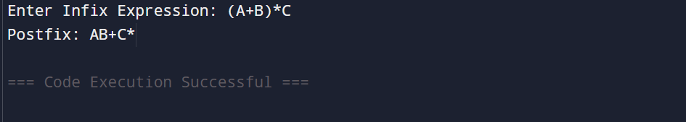

Q8:Write a program to perform the operations of the linked list:
- Insertion
- Deletion
- Display

#include <stdio.h>
#include <stdlib.h>

struct Node {
int data;
struct Node* next;
};

struct Node* head = NULL;

void insert(int x) {
struct Node* newNode = (struct Node*)malloc(sizeof(struct Node));
newNode->data = x;
newNode->next = head;
head = newNode;
}

void delete(int x) {
struct Node *temp = head, *prev = NULL;

if (temp != NULL && temp->data == x) {
head = temp->next;
free(temp);
return;
}

while (temp != NULL && temp->data != x) {
prev = temp;
temp = temp->next;
}

if (temp == NULL) return;

prev->next = temp->next;
free(temp);
}

void display() {
struct Node* temp = head;
while (temp != NULL) {
printf("%d ", temp->data);
temp = temp->next;
}
}

int main() {
insert(10);
insert(20);
insert(30);
printf("List after insertion: ");
display();

delete(20);
printf("\nList after deletion: ");
display();

return 0;
}

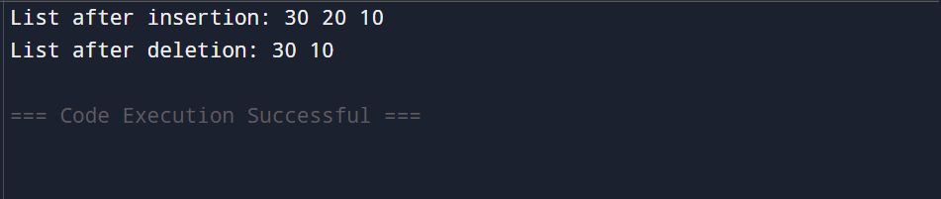

Q9:Write a program to perform the operations of the Circular linked list:
- Insertion
- Deletion
- Display

#include <stdio.h>
#include <stdlib.h>

struct Node {
int data;
struct Node* next;
};

struct Node* head = NULL;

void insert(int x) {
struct Node* newNode = (struct Node*)malloc(sizeof(struct Node));
newNode->data = x;

if (head == NULL) {
head = newNode;
newNode->next = head;
} else {
struct Node* temp = head;
while (temp->next != head)
temp = temp->next;
temp->next = newNode;
newNode->next = head;
}
}

void delete(int x) {
if (head == NULL) return;

struct Node *temp = head, *prev = NULL;

if (temp->data == x && temp->next == head) {
head = NULL;
free(temp);
return;
}

if (temp->data == x) {
while (temp->next != head)
temp = temp->next;
temp->next = head->next;
free(head);
head = temp->next;
return;
}

prev = head;
temp = head->next;

while (temp != head && temp->data != x) {
prev = temp;
temp = temp->next;
}

if (temp->data == x) {
prev->next = temp->next;
free(temp);
}
}

void display() {
if (head == NULL) return;

struct Node* temp = head;
do {
printf("%d ", temp->data);
temp = temp->next;
} while (temp != head);
}

int main() {
insert(10);
insert(20);
insert(30);

printf("Circular List after insertion: ");
display();

delete(20);
printf("\nCircular List after deletion: ");
display();

return 0;
}
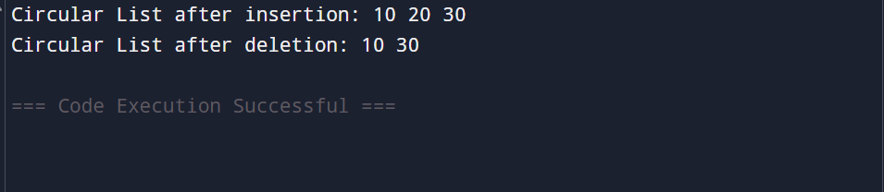

Q10:Write a program to perform all operations: -
- For Stack using Linked List.
- For Queue using Linked List
- For Circular Queue using Linked List

#include <stdio.h>
#include <stdlib.h>

struct Node { int data; struct Node* next; };
struct Node *top=NULL, *front=NULL, *rear=NULL;
struct Node *frontC=NULL, *rearC=NULL;

/* STACK */
void push(int x){
struct Node* n=malloc(sizeof(struct Node));
n->data=x; n->next=top; top=n;
}
void pop(){
if(!top) return;
struct Node* t=top; top=top->next; free(t);
}
void displayStack(){
struct Node* t=top;
while(t){ printf("%d ",t->data); t=t->next; }
}

/* QUEUE */
void enqueue(int x){
struct Node* n=malloc(sizeof(struct Node));
n->data=x; n->next=NULL;
if(!rear) front=rear=n;
else{ rear->next=n; rear=n; }
}
void dequeue(){
if(!front) return;
struct Node* t=front;
front=front->next;
if(!front) rear=NULL;
free(t);
}
void displayQueue(){
struct Node* t=front;
while(t){ printf("%d ",t->data); t=t->next; }
}

/* CIRCULAR QUEUE */
void enqueueC(int x){
struct Node* n=malloc(sizeof(struct Node));
n->data=x;
if(!frontC){
frontC=rearC=n;
rearC->next=frontC;
} else {
rearC->next=n;
rearC=n;
rearC->next=frontC;
}
}
void dequeueC(){
if(!frontC) return;
if(frontC==rearC){
free(frontC);
frontC=rearC=NULL;
return;
}
struct Node* t=frontC;
frontC=frontC->next;
rearC->next=frontC;
free(t);
}
void displayC(){
if(!frontC) return;
struct Node* t=frontC;
do{
printf("%d ",t->data);
t=t->next;
} while(t!=frontC);
}

int main(){
int ch, val;

while(1){
printf("\n\n1.Push(Stack)\n2.Pop(Stack)\n3.Display Stack");
printf("\n4.Enqueue(Queue)\n5.Dequeue(Queue)\n6.Display Queue");
printf("\n7.Enqueue(Circular Queue)\n8.Dequeue(CQ)\n9.Display CQ");
printf("\n10.Exit\nEnter choice: ");
scanf("%d",&ch);

if(ch==10) break;

switch(ch){
case 1: printf("Enter value: "); scanf("%d",&val); push(val); break;
case 2: pop(); break;
case 3: displayStack(); break;

case 4: printf("Enter value: "); scanf("%d",&val); enqueue(val); break;
case 5: dequeue(); break;
case 6: displayQueue(); break;

case 7: printf("Enter value: "); scanf("%d",&val); enqueueC(val); break;
case 8: dequeueC(); break;
case 9: displayC(); break;
}
}
return 0;
}

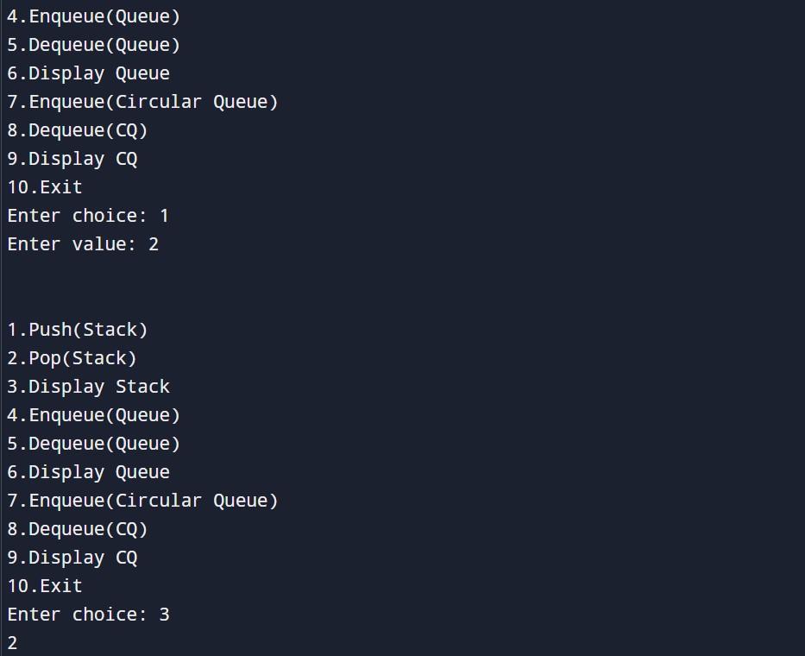

Q11:Write a program to perform concatenation of two linked lists.
#include <stdio.h>
#include <stdlib.h>

struct Node {
int data;
struct Node* next;
};

struct Node* createNode(int x) {
struct Node* n = malloc(sizeof(struct Node));
n->data = x;
n->next = NULL;
return n;
}

void insert(struct Node** head, int x) {
struct Node* n = createNode(x);
n->next = *head;
*head = n;
}

struct Node* concatenate(struct Node* a, struct Node* b) {
if (a == NULL) return b;
struct Node* temp = a;
while (temp->next != NULL)
temp = temp->next;
temp->next = b;
return a;
}

void display(struct Node* head) {
while (head) {
printf("%d ", head->data);
head = head->next;
}
}

int main() {
struct Node *list1 = NULL, *list2 = NULL;

insert(&list1, 30);
insert(&list1, 20);
insert(&list1, 10);

insert(&list2, 60);
insert(&list2, 50);
insert(&list2, 40);

printf("List 1: ");
display(list1);
printf("\nList 2: ");
display(list2);

list1 = concatenate(list1, list2);

printf("\nConcatenated List: ");
display(list1);

return 0;
}
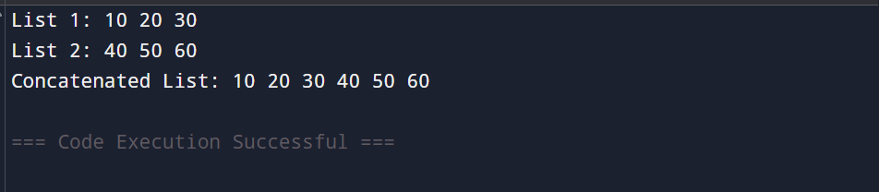

Q12:Write a program to perform the operations of the Double linked list:
- Insertion
- Deletion
- Display

#include <stdio.h>
#include <stdlib.h>

struct Node {
int data;
struct Node *prev, *next;
};

struct Node* head = NULL;

void insert(int x) {
struct Node* n = malloc(sizeof(struct Node));
n->data = x;
n->prev = NULL;
n->next = head;

if (head != NULL)
head->prev = n;

head = n;
}

void delete(int x) {
struct Node* temp = head;

while (temp && temp->data != x)
temp = temp->next;

if (!temp) return;

if (temp->prev)
temp->prev->next = temp->next;
else
head = temp->next;

if (temp->next)
temp->next->prev = temp->prev;

free(temp);
}

void display() {
struct Node* temp = head;
while (temp) {
printf("%d ", temp->data);
temp = temp->next;
}
}

int main() {
insert(10);
insert(20);
insert(30);

printf("Doubly Linked List after insertion: ");
display();

delete(20);
printf("\nDoubly Linked List after deletion: ");
display();

return 0;
}
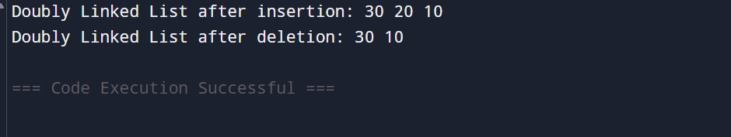

Q13:Write a program to perform tree traversal methods.

#include <stdio.h>
#include <stdlib.h>

struct Node {
int data;
struct Node *left, *right;
};

struct Node* create(int x) {
struct Node* n = malloc(sizeof(struct Node));
n->data = x;
n->left = n->right = NULL;
return n;
}

void inorder(struct Node* root) {
if (!root) return;
inorder(root->left);
printf("%d ", root->data);
inorder(root->right);
}

void preorder(struct Node* root) {
if (!root) return;
printf("%d ", root->data);
preorder(root->left);
preorder(root->right);
}

void postorder(struct Node* root) {
if (!root) return;
postorder(root->left);
postorder(root->right);
printf("%d ", root->data);
}

int main() {
struct Node* root = create(10);
root->left = create(20);
root->right = create(30);
root->left->left = create(40);
root->left->right = create(50);

printf("Inorder: ");
inorder(root);

printf("\nPreorder: ");
preorder(root);

printf("\nPostorder: ");
postorder(root);

return 0;
}
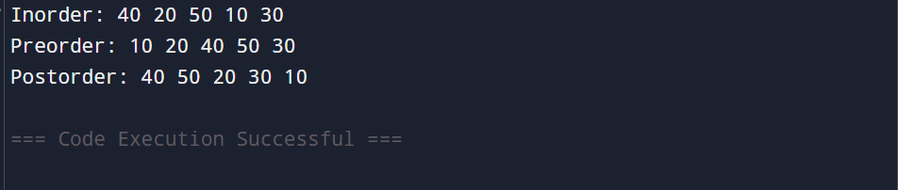

Q14:Write a program to perform insertion and deletion in the Binary Search Tree.
#include <stdio.h>
#include <stdlib.h>

struct Node {
int data;
struct Node *left, *right;
};

struct Node* create(int x) {
struct Node* n = malloc(sizeof(struct Node));
n->data = x;
n->left = n->right = NULL;
return n;
}

struct Node* insert(struct Node* root, int x) {
if (!root) return create(x);
if (x < root->data)
root->left = insert(root->left, x);
else
root->right = insert(root->right, x);
return root;
}

struct Node* minValueNode(struct Node* root) {
while (root->left)
root = root->left;
return root;
}

struct Node* delete(struct Node* root, int x) {
if (!root) return root;

if (x < root->data)
root->left = delete(root->left, x);
else if (x > root->data)
root->right = delete(root->right, x);
else {
if (!root->left) {
struct Node* t = root->right;
free(root);
return t;
}
else if (!root->right) {
struct Node* t = root->left;
free(root);
return t;
}
struct Node* t = minValueNode(root->right);
root->data = t->data;
root->right = delete(root->right, t->data);
}
return root;
}

void inorder(struct Node* root) {
if (!root) return;
inorder(root->left);
printf("%d ", root->data);
inorder(root->right);
}

int main() {
struct Node* root = NULL;

root = insert(root, 50);
root = insert(root, 30);
root = insert(root, 70);
root = insert(root, 20);
root = insert(root, 40);

printf("BST Inorder (After Insertion): ");
inorder(root);

root = delete(root, 30);

printf("\nBST Inorder (After Deletion): ");
inorder(root);

return 0;
}
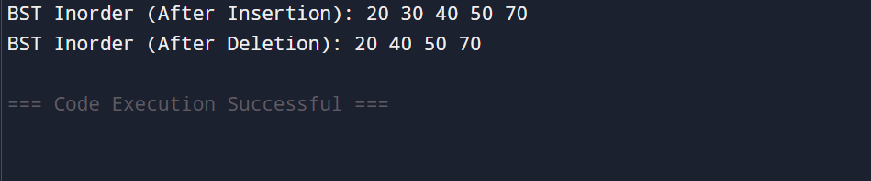

Q15:Write a program to represent an undirected graph using the adjacency matrix to implement the graph and perform the operations with menu-driven options for the following tasks:
1. Create graph 2. Insert an edge 3. Print Adjacency Matrix 4. List all vertices that are adjacent to a specified vertex. 6.
Exit program

#include <stdio.h>

int graph[20][20];
int n;

void createGraph() {
int i, j;
printf("Enter number of vertices: ");
scanf("%d", &n);

printf("Enter adjacency matrix (%d x %d):\n", n, n);
for (i = 0; i < n; i++)
for (j = 0; j < n; j++)
scanf("%d", &graph[i][j]);
}

void insertEdge() {
int u, v;
printf("Enter edge (u v): ");
scanf("%d %d", &u, &v);

graph[u][v] = 1;
graph[v][u] = 1;
}

void printMatrix() {
int i, j;
printf("Adjacency Matrix:\n");
for (i = 0; i < n; i++) {
for (j = 0; j < n; j++)
printf("%d ", graph[i][j]);
printf("\n");
}
}

void adjacentVertices() {
int v, i;
printf("Enter vertex: ");
scanf("%d", &v);

printf("Vertices adjacent to %d: ", v);
for (i = 0; i < n; i++)
if (graph[v][i] == 1)
printf("%d ", i);
}

int main() {
int ch;

while (1) {
printf("\n1.Create Graph\n2.Insert Edge\n3.Print Matrix\n4.Adjacent Vertices\n5.Exit\n");
printf("Enter choice: ");
scanf("%d", &ch);

switch (ch) {
case 1: createGraph(); break;
case 2: insertEdge(); break;
case 3: printMatrix(); break;
case 4: adjacentVertices(); break;
case 5: return 0;
default: printf("Invalid Choice");
}
}
}
